# 



# Solaqua Project Documentation

1. **Client Questionnaire**
2. **Visual Hierarchy**
3. **Project Plan**
4. **Prototype**
5. **Mockup**
6. **Signoff Form**

# Client Questionnaire

# Contact info:

James Holden CEO [JamesH@solaqua.com](mailto:JamesH@solaqua.com)

# Business info

Solaqua,

Unit 6A,

Eastgate Business Park,

Little Island,

Co. Cork.

Q37X058

021 4355254

[info@solaqua.com](mailto:info@solaqua.com)

## Questions:

**Tell us what your company does?**

**We design and create solar panels of all sizes**

**What’s your deadline for this project?**

**28 July 2018**

**What do you want from this website?**

1. I need people to be able to contact us through the site, make enquiries, or request an installation.
2. I need to build awareness for my brand

**My clients come to me because:**

I have the best products on the market. And can build custom systems too.

**Visitor and customer demographic:**

**In their 30s and 40’s.**

**Target market?**

**Environmental and energy conscious people.**

**Small to medium size companies.**

**Solar charge points for vehicles and electronic road signs**

**What is your customers Target Income:**

**Employed and Affluent**

**My site will be built to target (geography)**

National (Ireland)

**Do you want to expand your target audience in a specific direction?**

**Yes. We want to expand from domestic solar panels, into the automotive industry, mainly electric cars, and products of various sizes, eg, for camping and travel..**

**What is it that makes your or services unique on the market?**

**As well as solar panel home installations, we have begun production of domestic solar charging stations, with built in storage, for electric vehicles. We don’t just import solar panels, we design and create them in various sizes for multiple purposes.**

**Do you have any proof that your solutions are better than your competitors?**

**No**

**Our new website would need to include:**

A basic HTML site ☐

An HTML5/ CSS3 website x

Responsive design for use on tablets & mobiles x

A WordPress-based CMS ☐

Online Magazine ☐

Online forum/ blog ☐

Newsletter system x

Social network integration ☐

Intranet system ☐

Separate, dedicated landing pages ☐

A redesign of a current website ☐

Additional requirements _____ **It would be nice to have some simple animations on the site, if you can do something that blends well with the theme, or gives the page a bit of life, but it’s optional**.

**We want the following special features to be included in our new website:**

Registration form ☐

Video streaming ☐

MySQL Database ☐

Search panel ☐

Multicolumn layout x

Newsletter/ Email sign up forms x

Information/ request forms ☐

Uploads/ downloads ☐

Customer login ☐

Registration ☐

An online store/shopping cart ☐

Online payment gateway ☐

Blog module ☐

Image gallery x

Image slider ☐

Other features _________ **A contact form, an about us page and, some news that updates itself if that’s possible. Otherwise just some generic info about solar energy, we can provide this if necessary.**

**What content will you provide?**

**Logo, and all media and text content.**

**Do you have a branding\colour scheme in mind?**

**Yes, partly. We would like a bright page, containing some green to reflect solar power and the connection to renewable energy, and if possible some blue to resemble water, from our name.**

**And perhaps a shining sun in the background somewhere.**

# Visual hierarchy:

**Mobile first:**

**HOME**

nav

Logo: top left, hamburger nav (Light transparent nav at top right for larger screens)

Weather API: top-far-right corner (just text for mobile, icon for large screens)

main

Landing page with slogan, and short info

Intro about company

Large image

4 Columns containing brief product description: link to products (ajax)

Another image

Info about solar battery\station

**Gallery** (two-three images, the rest on separate page)

images same nav and theme (see more button for mobile, separate page)

**Products** (separate page)

4 columns headings with an image each

When clicked, opens selected product in an ajax window in the same page

Product contains an image and text, maybe a link to order, link to contact page, or text saying contact us

**News** (short, maybe more on a separate page)

https://feeds.feedburner.com/SolarEnergyrssFeed

**About us**

large image,

installation

paragraph

**Contact us**

google maps

contact form

contact info

# Project Plan:

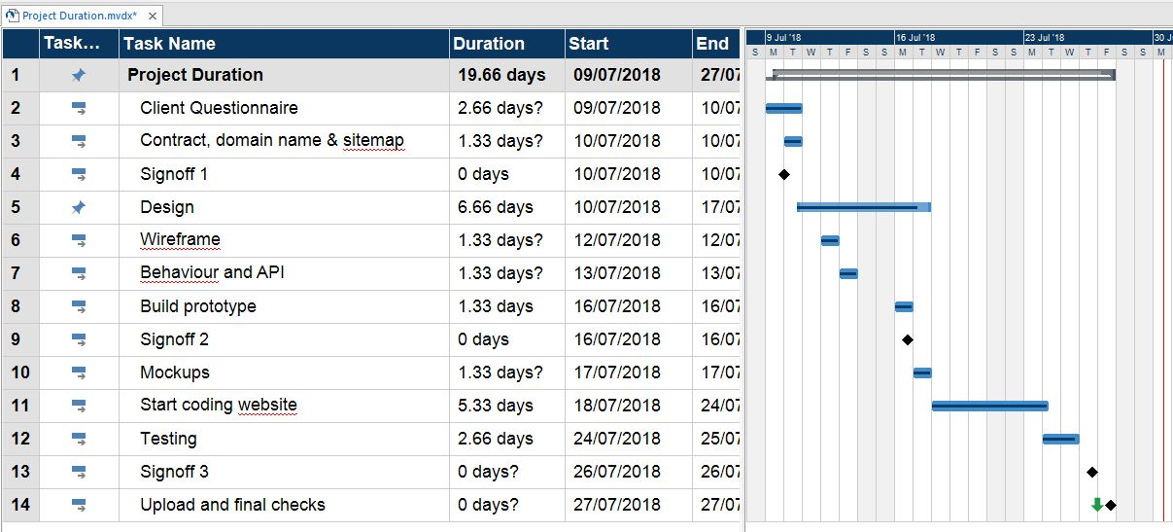

# Protoypes:

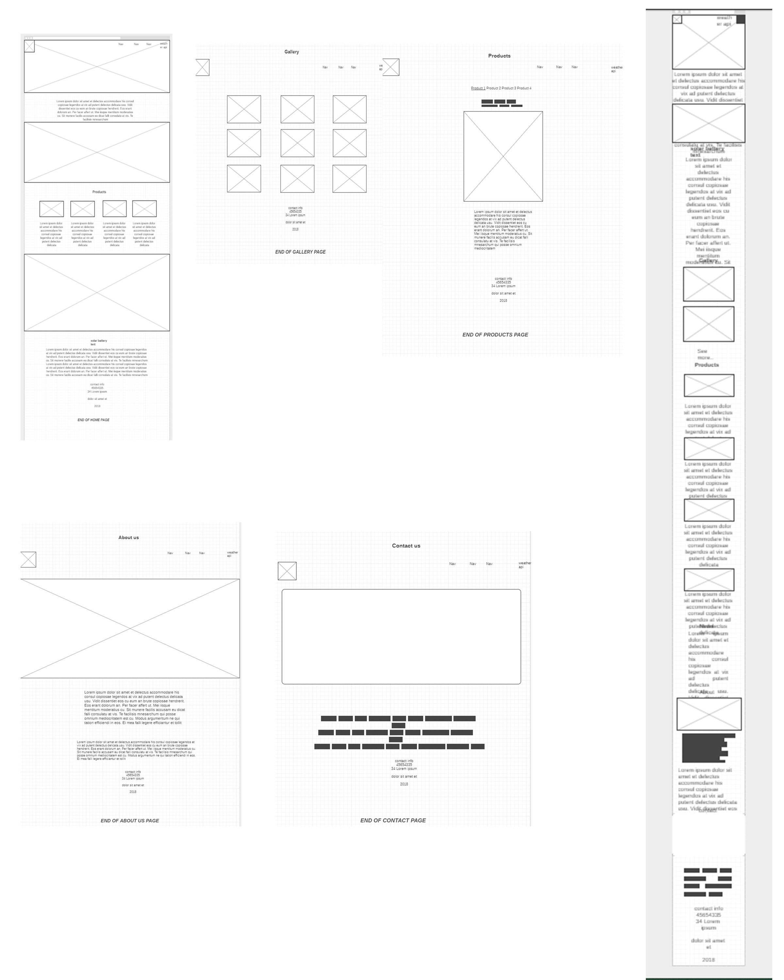

# Mockup:

# C:\Users\DP9\AppData\Local\Microsoft\Windows\INetCache\Content.Word\mockuptopDesktop.jpg

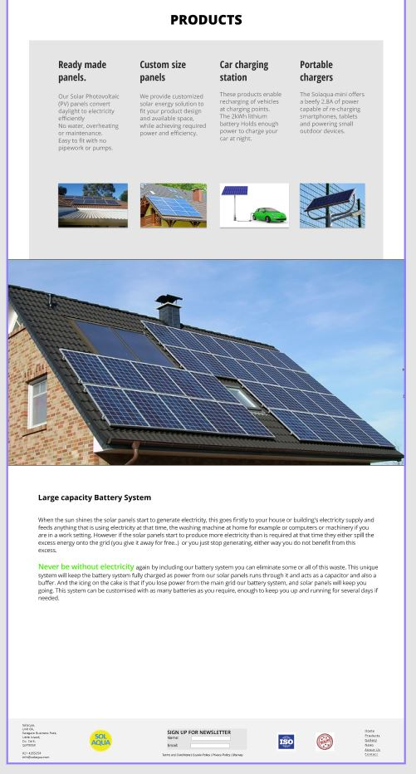

# **Signoff Form**

***[30% after discussion and sitemap***

***30% on prototype***

***40% on completion]***

**To be signed after questionnaire, discussion and sitemap:**

______________________________________________

***[Client Name]***

______________________________________________

***[Position]***

______________________________________________________________________________________

Sign here to approve ***[Date]***

**Terms**

*By signing above, I have agreed that the process so far is acceptable and agree to proceed to the next stage of development.*

**To be signed after prototype is created and agreed upon:**

______________________________________________

***[Client Name]***

______________________________________________

***[Position]***

______________________________________________________________________________________

Sign here to approve ***[Date]***

**Terms**

*By signing above, I have agreed that the process so far is acceptable and agree to proceed to the next stage of development.*

**To be signed after website is completed and agreement that all proposals have been met:**

______________________________________________

***[Client Name]***

______________________________________________

***[Position]***

______________________________________________________________________________________

Sign here to approve ***[Date]***

**Terms**

*By signing above, I have agreed that the process so far is acceptable and agree to proceed to the next stage of development.*

**Project Specifications & Pricing**